L.J. INSTITUTE OF COMPUTER APPLICATIONS



My Show

**Movie booking system**



|  |  |
| --- | --- |
| sr. no | title |
| 1 | introduction |
| 2 | existing system |
| 3 | praposed system |
| 4 | targeted user |
| 5 | data dicsanary |
| 6 | usae case |

# **Developer information**

* **Miss**. Neha Agrawal (E.N:- 2020004500210004)
* **Miss**. Tisha Sadariya (E.N:- 2020004500210052)
* **Mr**. Vraj Parikh (E.N:- 2020004500210037)
* **Internal Guide**:- Prof. Aafrin Julaya

# **1.Introduction**

* My Show is a website for Online Ticket Booking for Movies.
* This is an online website on which user as well as theater owner (admin) register themselves and use this site.
* Theater owner use this website for add/update and delete movies and search for particular location of theater.
* User book ticket for particular movie and search movie as well as choose movie to particular location.
* The goal of this system is to provide easy way to book Movie Ticket.

# **2.Existing System**

* User doesn’t have to wait to see the movie or buy tickets.
* User won’t have to stand in line to get a movie tickets.
* User easily sees which seat is booked and which seat is not.

# **3.Proposed system**

* The main purpose of My show project is to provide an automated system of buying movie ticket.
* Admin has full control over all modules of this application. Admin can add new movie details and poster.
* Customers can view Movie Details and book ticket on their desired choice.
* Customers should register themselves on the web portal for buying ticket.
* This system provide offers which make by admin for users.

# **4.Targeted User**

1. **Admin :**

* Admin can Login a System
* Admin can add/update/delete movie details
* Add city and theater
* Admin also add particular theater sets.

1. **User :**

* User Can Register and Login a System.
* User saw the particular and trending Movie.
* User can saw particular movie details.
* User can Book movie ticket and choose theater and city.

# **5.Database Dictionary**

1. User
2. Movie
3. Actor
4. Cast
5. Cities
6. Theater
7. Seat

**1. User**

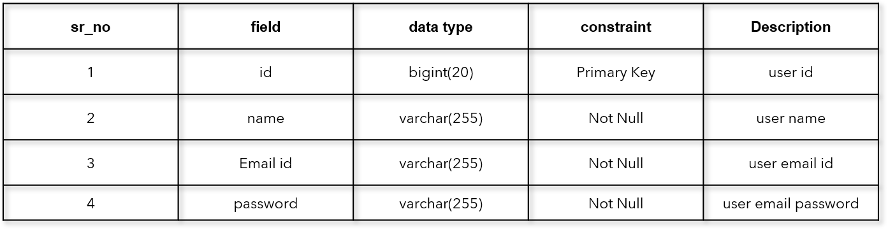

**2. Movie**

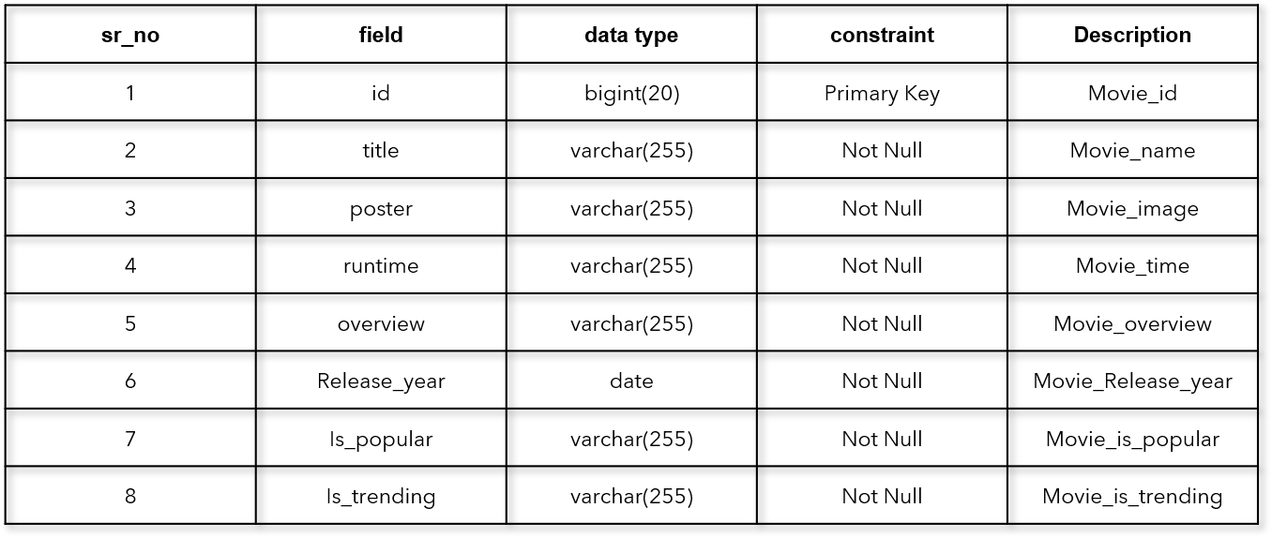

1. **Actor**

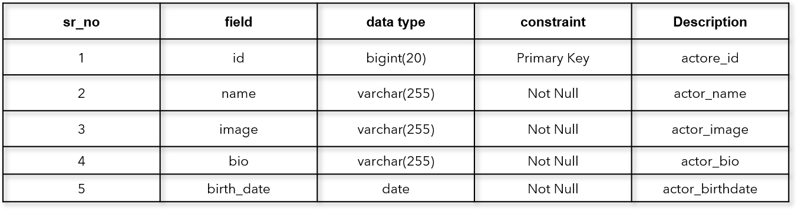

1. **Cast**

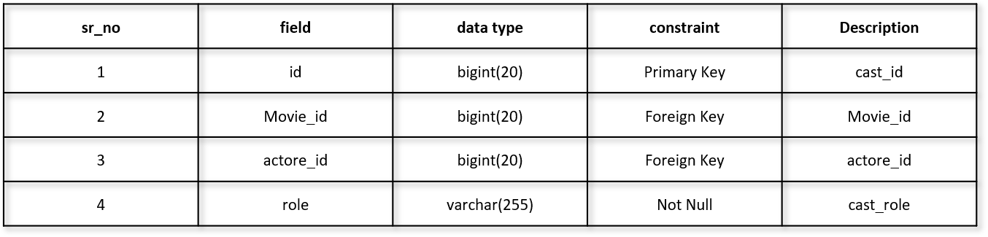

1. **Cities**

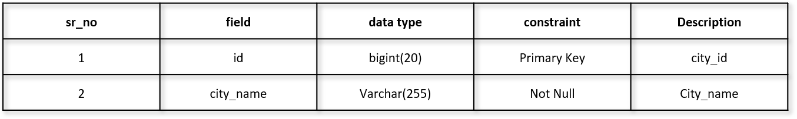

1. **Theater**

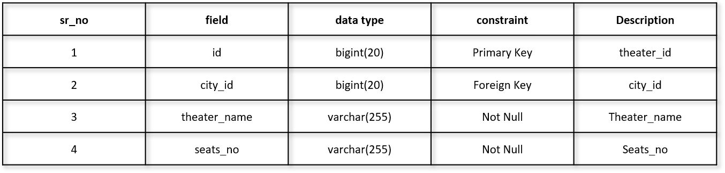

1. **Seats**

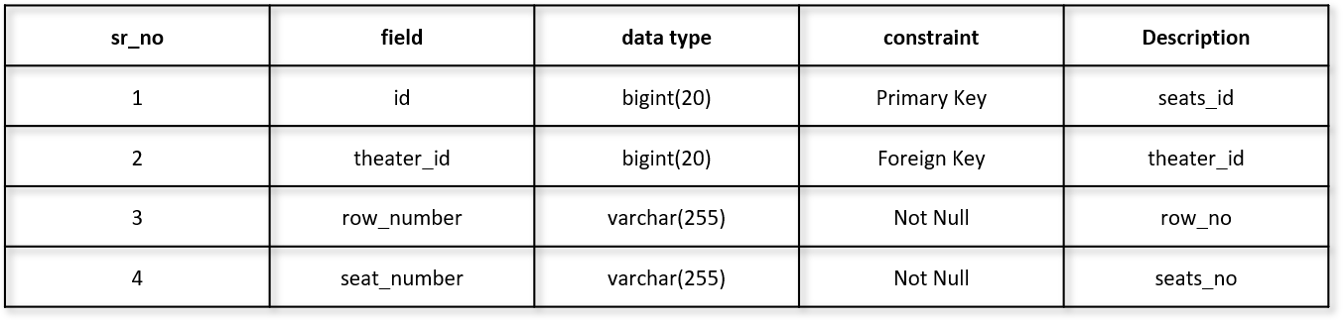

# **6. Use case**

